

Cakes By Mary Bell



Claudia Rojas

Database Systems

CMPT 308

Fall 2016

Table of Contents

Executive Summary 4

Overview 4

Objectives 4

Entity Relationship Diagram 5

Tables 5

Store 6

People 7

Suppliers 8

Inventory 9

Ingredients 10

Recipe 11

Orders 12

Employees 13

Baker 14

Deliverer 15

Customers 16

Views 17

DelivererJobs 17

BakerJobs 18

LocationofCustomerOrders 19

Reports 20

Average Completion of Orders 20

Average Ingredients in a Recipe 21

Triggers 22

AddNewOrders 22

AddNewInventory 22

AddNewPerson 22

AddNewEmployee 23

Stored Procedures 24

InsertOrders 24

InsertItem 24

InsertPerson 25

InsertEmployees 25

Security 26

Administrator 26

Employees 26

Deliverers 26

Bakers 26

Manager 27

Implementation Notes 28

Known Problems 29

Future Enhancements 30

# Executive Summary

## Overview

The customer, Cakes by Mary Bell, is an up-and-coming family business that is ready to open in the next few months. They have requested to create a database for their business to keep track of their employees, customers, and orders. The customer has also stated that they would like to keep an “open mind” to the database to allow for expansion. They would like the database to allow for the implementation of many stores in the future

## Objectives

This document describes the database system that was created and filled with data to mimic how the database for the store will look. The purpose of the database is to show how the store will be run according to the database system. The database stores all the information of customers, employees, orders, and an inventory of items currently within one store.

The document will provide a detail look into each section within the database and will describe the implementation of the database. The document will include: tables and their functions, views, triggers, stored procedures, and security.

# Entity Relationship Diagram

# Tables

## Store

This table stores the information of different stores and allows for the inclusion of different stores in the database. The store includes information about its location and the profits it earns per month.

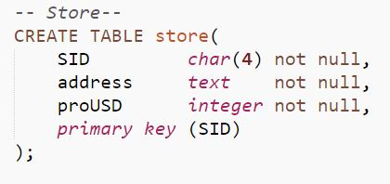

Functional Dependencies

SID address, ProUSD

Sample Data

## People

This table keeps track of the people who are either customers of the store or are employees working in the store.

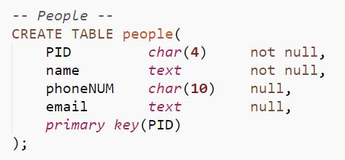

Functional Dependencies

PID name, phoneNUM, email

Sample Data

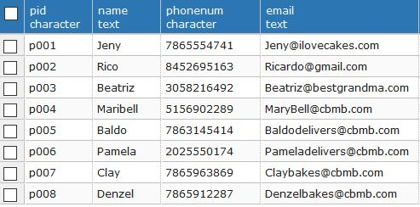

## Suppliers

This table contains the information of the different suppliers that supply the store with inventory items to keep it up and running.

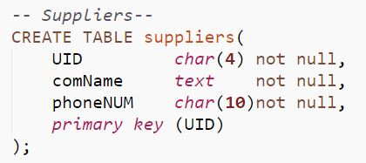

Functional Dependencies

UID comName, PhoneNUM

Sample Data

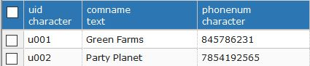

## Inventory

This table contains the inventory information for the items that are used in certain recipes for different cake orders.

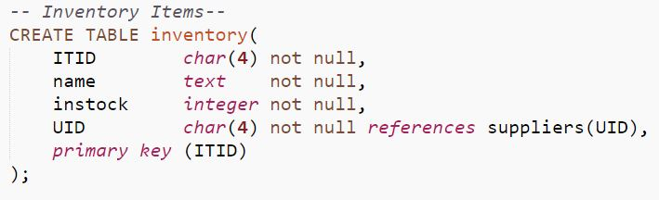

Functional Dependencies

ITID name, instock, UID

Sample Data

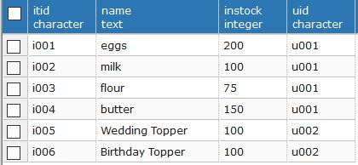

## Ingredients

This table is a cross reference of the different ingredients needed for different recipes in an order.

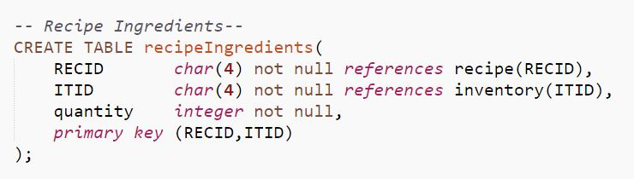

Functional Dependencies

RECID, ITID quantity

Sample Data

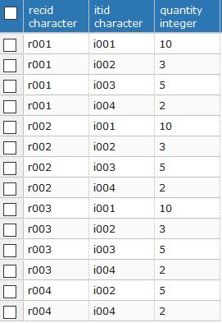

## Recipe

This table contains the name and ID of the recipes used in the cake orders.

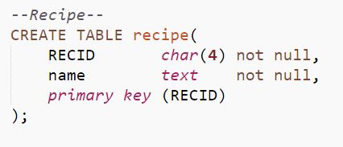

Functional Dependencies

RECID name

Sample Data

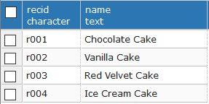

## Orders

This table contains all the information that is needed within an order. This table is important because it is keeps tracks of all the orders within the store.

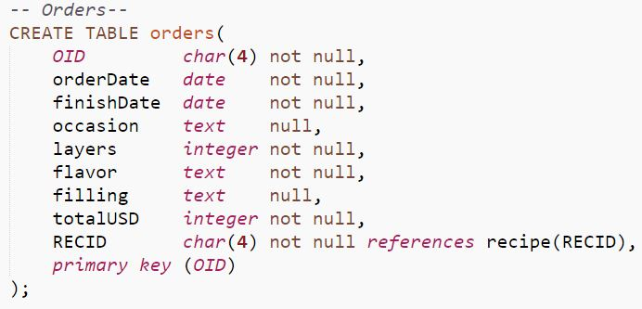

Functional Dependencies

OID orderDate, finishDate, occasion, layers, flavor, filling, totalUSD, RECID

Sample Data

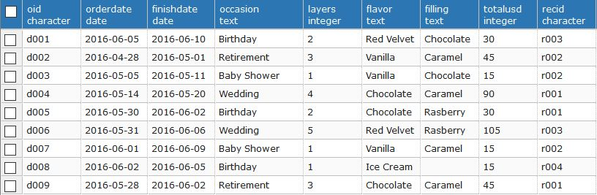

## Employees

This table contains the information of each employee that works in a certain store. The employee table contains only half of the employee information because the people table contains the email and phone numbers of the employees.

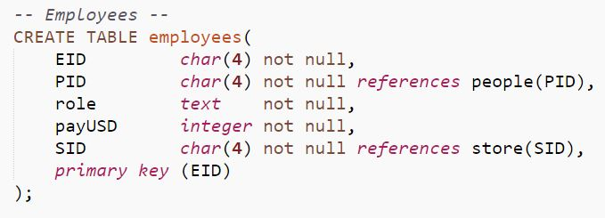

Functional Dependencies

EID PID, role, payUSD, SID

Sample Data

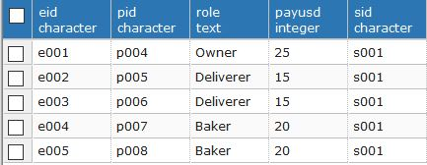

## Baker

This table is a combination of the employee ID and the order ID which allows for different bakers to work on different cakes. It also allows for bakers to work on the same cakes at once.

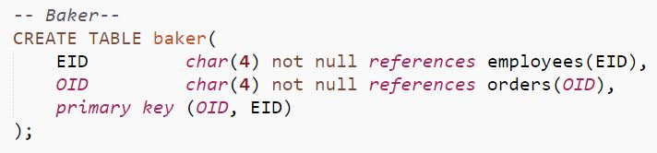

Functional Dependencies

EID, OID

Sample Data

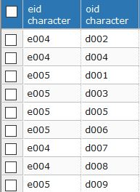

## Deliverer

This table contains the information needed for a cake delivery. The primary key for the deliverer table is a composite of the employee ID and orders ID. Like the bakers table it also allows for multiple deliverers to go out for the same delivery if it is needed.

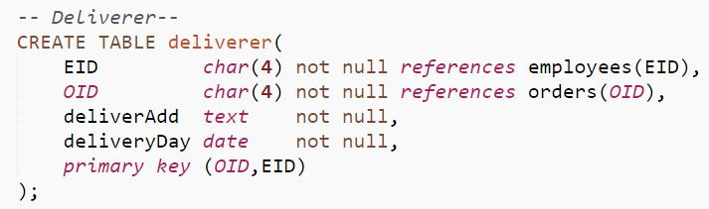

Functional Dependencies

EID, OID deliverAdd, deliveryDay

Sample Data

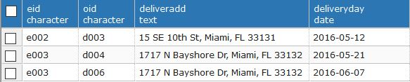

## Customers

This table contains the PID and other information for the people who are customers of a store.

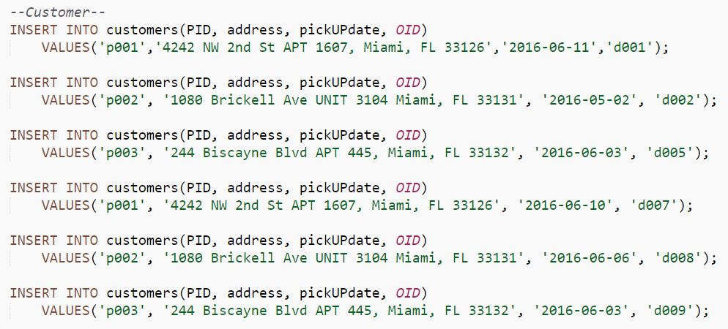

Functional Dependencies

PID address, pickUPdate, OID

Sample Data

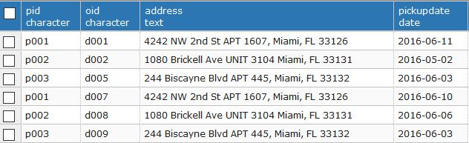

# Views

## DelivererJobs

This table shows the name, phone number, email address, role, pay in US dollars, and store id of a deliverer dependent on the multiple orders they have done for Cakes by Mary Bell.

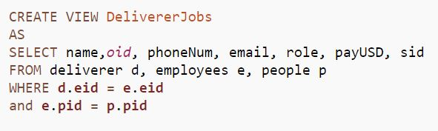

Sample Data

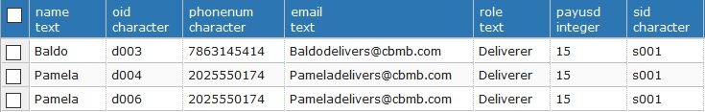

## BakerJobs

Like DelivererJob, BakerJobs shows all the orders done by a baker including details about their phonenumber, email, role, pay in US dollars, and store ID.

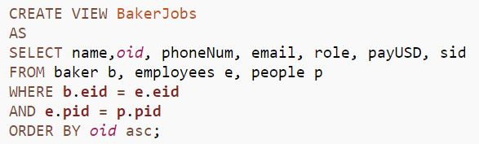

Sample Data

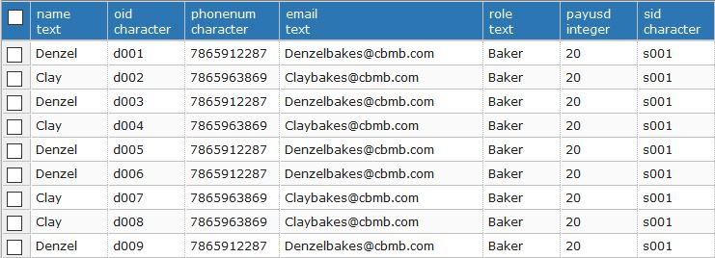

## LocationofCustomerOrders

These views show the different areas customers who have purchased a cake from Cakes By Mary Bell.

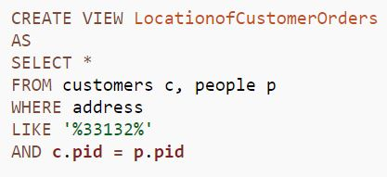

Sample Data

# Reports

## Average Completion of Orders

It is important for the business to know when each order is getting completed and how long it takes to complete them to ensure that the business is running and taking in orders and making sales.

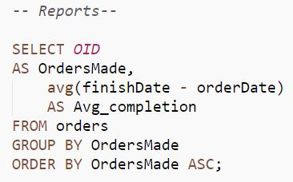

Sample Data

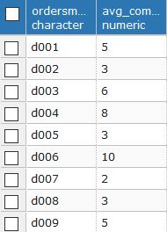

## Average Ingredients in a Recipe

It is essential to know how many ingredients are used in a recipe to be able to see when new ingredients need to be ordered.

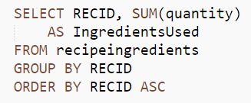

Sample Data

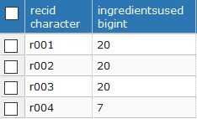

# Triggers

## AddNewOrders

When a new order is being inputted then the Orders table must be updated, which also updates the customers table and baker table.

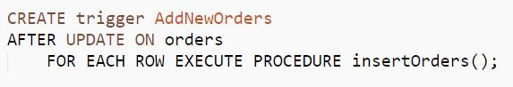

## AddNewInventory

When a new item comes into the store it must be checked into by an employee and inputted into the inventory table.

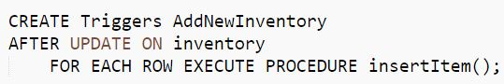

## AddNewPerson

Whenever a new customer or employee comes into the store they should be added to the people table in order to be able to keep track of the people that are associated with the shop

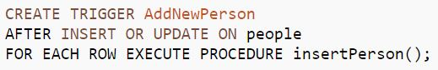

## AddNewEmployee

When a new employee is hired they should be given a role, pay in US dollars, and ID. They should also provide their information in order to be added into the people table.

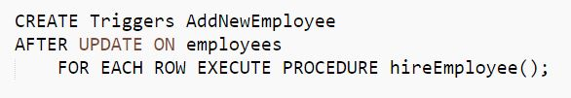

# Stored Procedures

## InsertOrders

For a new order to be inserted into the Order table it must be filled out on paper while in the store or done online.

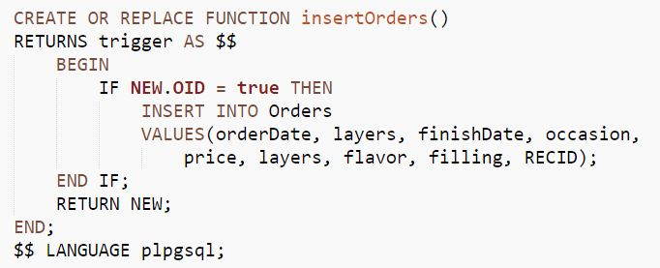

## InsertItem

Whenever a new item is ordered and delivered it must be entered in the inventory table with the correct quantity.

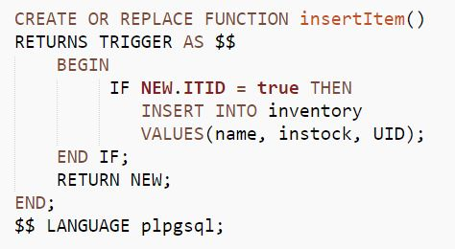

## InsertPerson

In this case, in order for a new employee to be inputted into the employees table they must first be inserted into the people table.

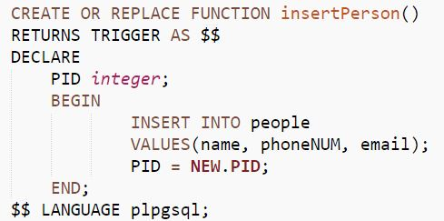

## InsertEmployees

Once they have been inserted into the people table the employee can now be inserted into the employees table

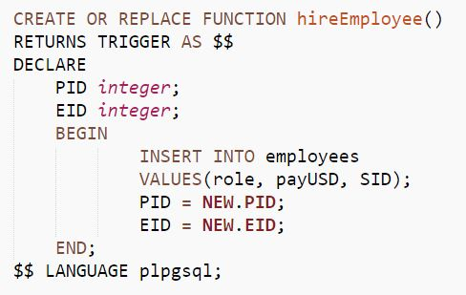

# Security

## Administrator

The administrator should have the highest privileges because they are can change and update the table in whatever manner that benefits the store.



## Employees

The employees should be able to see their individual employee data but should not be able to make changes on them.



## Deliverers

The employees who do deliveries should be able to see and add a new delivery they are doing. They should not be able to update it as that may create conflict.



## Bakers

The bakers should also be given the chance to insert and see the cakes they have worked on and the cakes other bakers are working on. Bakers should also be able to check the order specifications to be able to make a cake.

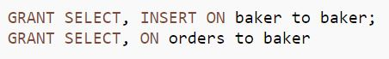

## Manager

Above the employees is the manager who should be able to select, insert, and update in the orders, employees, deliverer, bakers, and inventory tables.

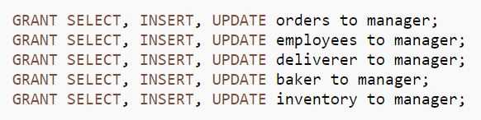

# Implementation Notes

* The orders must be fully filled out before they are submitted into the database. The finish date can be left empty until the cake has been finished.
* Once a customer has picked up and paid for a cake the date which they came must be entered into the database.
* If a new store is created, then there would be different SID for that store but the suppliers would still be the same. The new store would have to change its name to “Branch One” while the original store would have to change its name to “Main Store”.
* The administrator has the highest amount of access because they can select, insert, or update a supplier and the people table.
* Customers are automatically entered into the database but they cannot be removed or changed by the manager.

# Known Problems

* The bakers table needs further information as to what sets it apart from the employees table.
* The store table needs more information about a certain store. In the future it may include a column that states the amount of employees working in a specific store or he customers visiting the store per day.
* For a customer to change their order they must call the manager in order to update it. If they wanted to change their order they should be able to do so if they go online and submit a form.
* Only customers who have made an order appear on the customers table. Should a customer still be allowed into the table if they made an order but it was cancelled?

# Future Enhancements

* Once a new store opens then the store tables should be updated.
* There should be a shift table in order to allow shifts for employees.